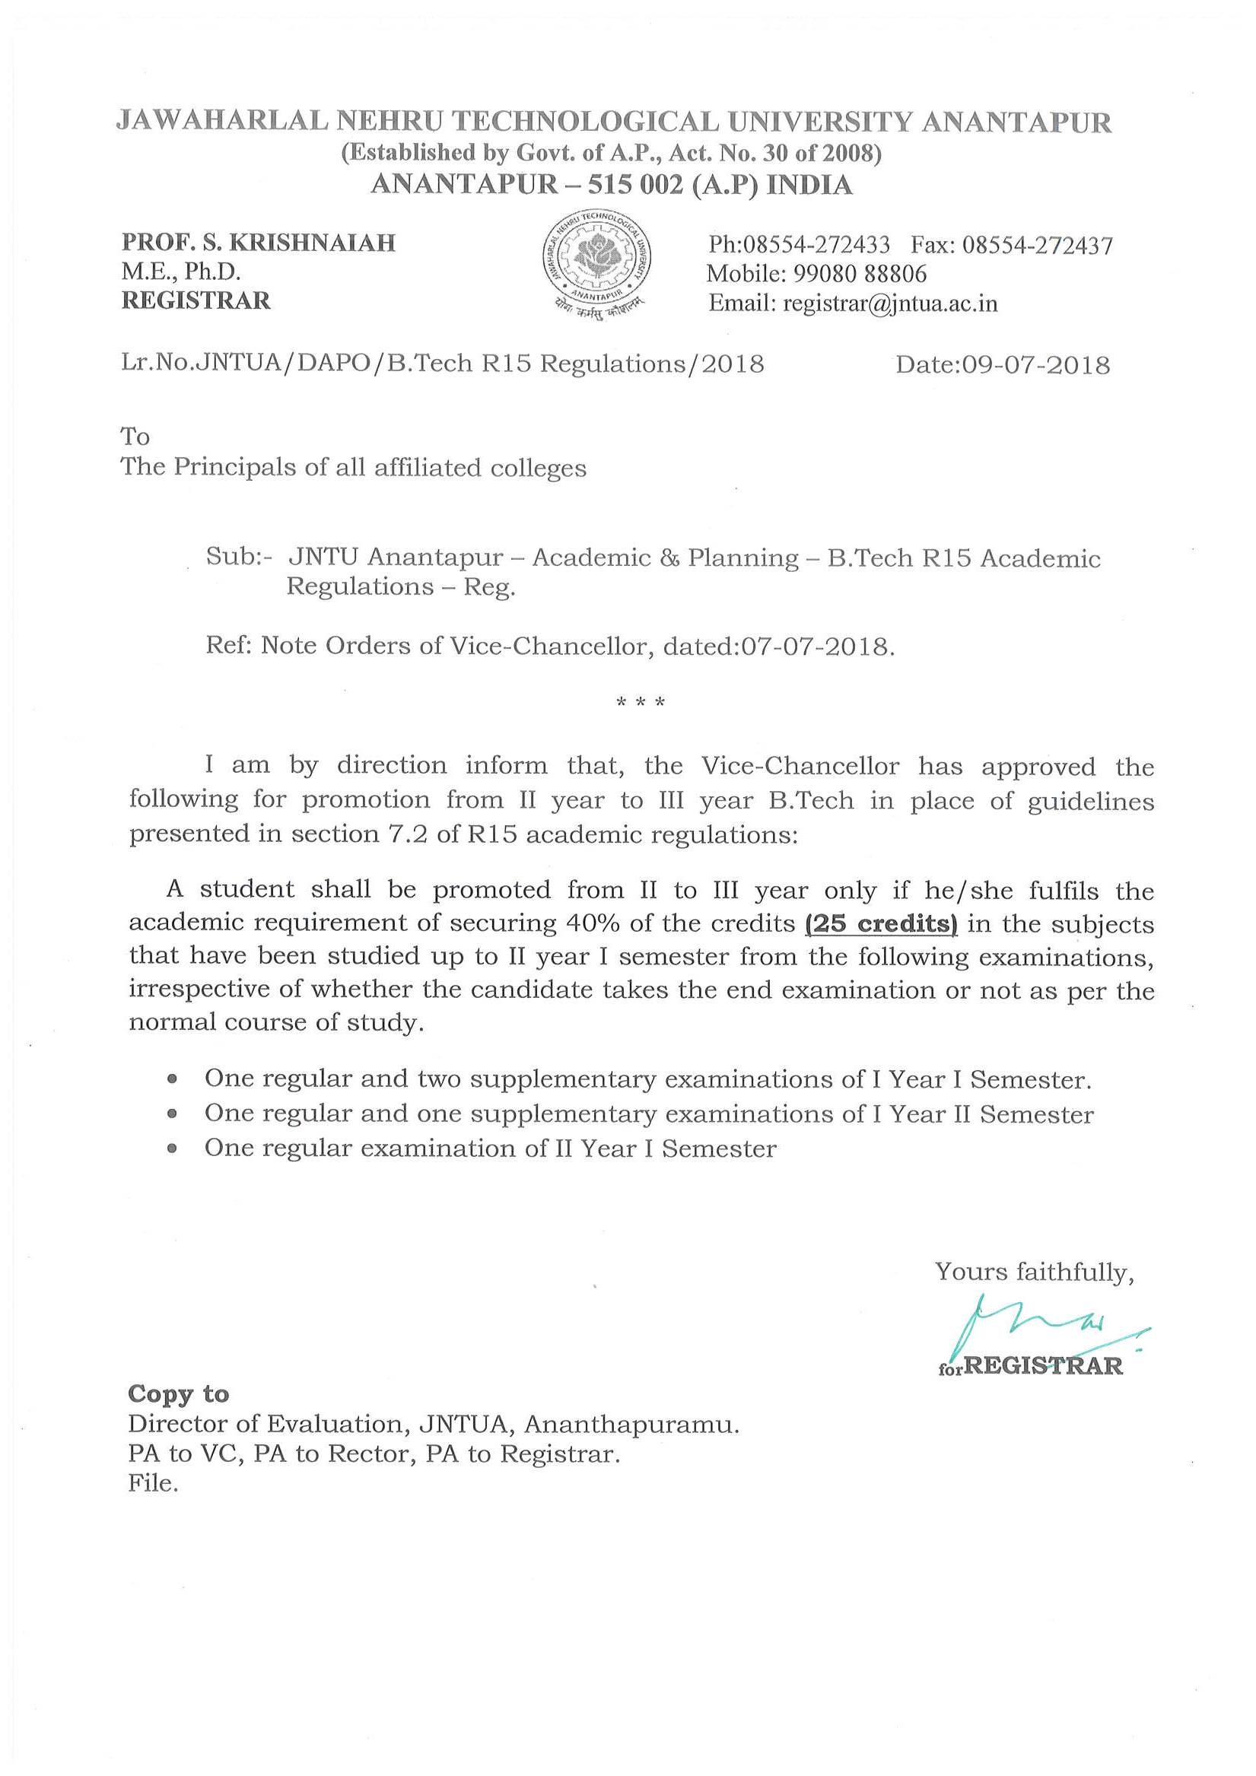
Number of Examinations to be considered for calculation of credits for promotion from II Year to III Year B.Tech courses.

